**Task 1**

Q1. Install Jupyter notebook and run the first program and share the screenshot of the output.

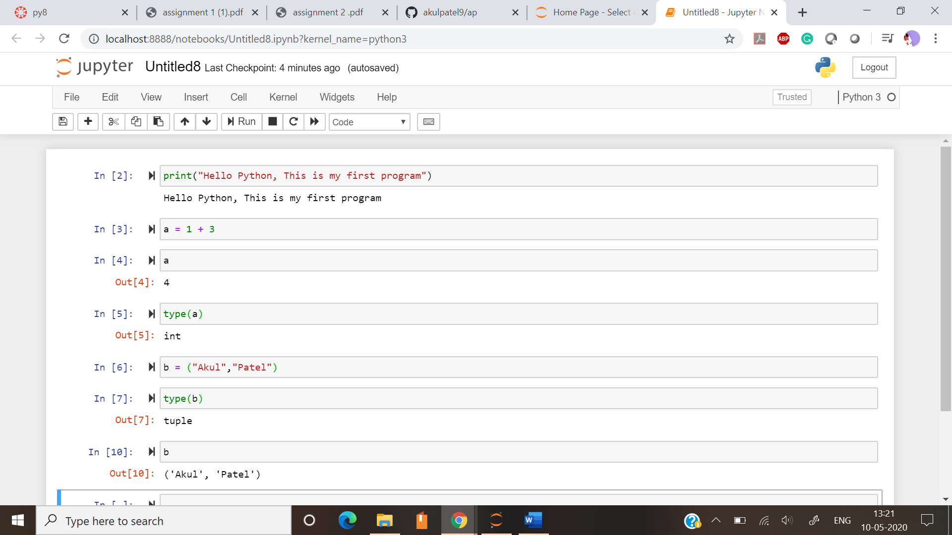

Q2. Write a program which will find all such numbers which are divisible by 7 but are not a multiple of 5, between 2000 and 3200 (both included). The numbers obtained should be printed in a comma-separated sequence on a single line.

Ans:

for x in range(2000,3200):

if (x%7==0) and (x%5!=0):

print (x,end=' ')

print("\b")

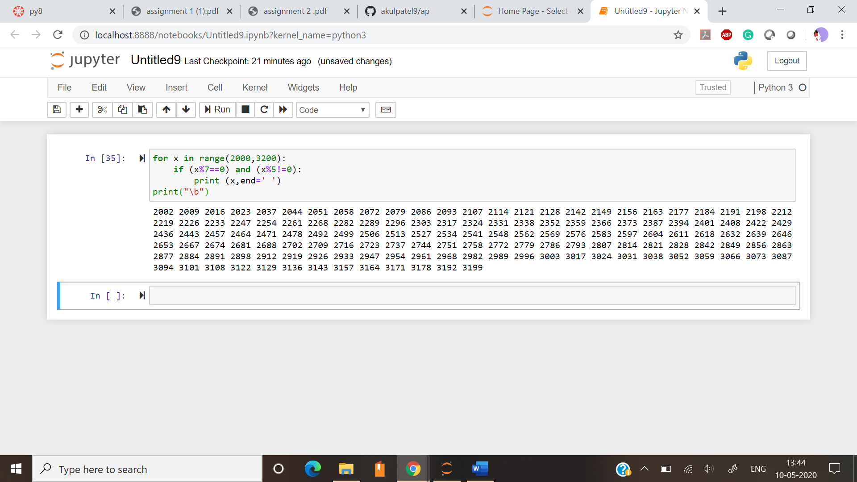

Q3. Write a Python program to accept the user's first and last name and then getting them printed in the reverse order with a space between first name and last name.

Ans:

f_name = str(input('enter your first name:'))

l_name = str(input('enter your last name:'))

print(first[::-1] + ' ' + last[::-1])

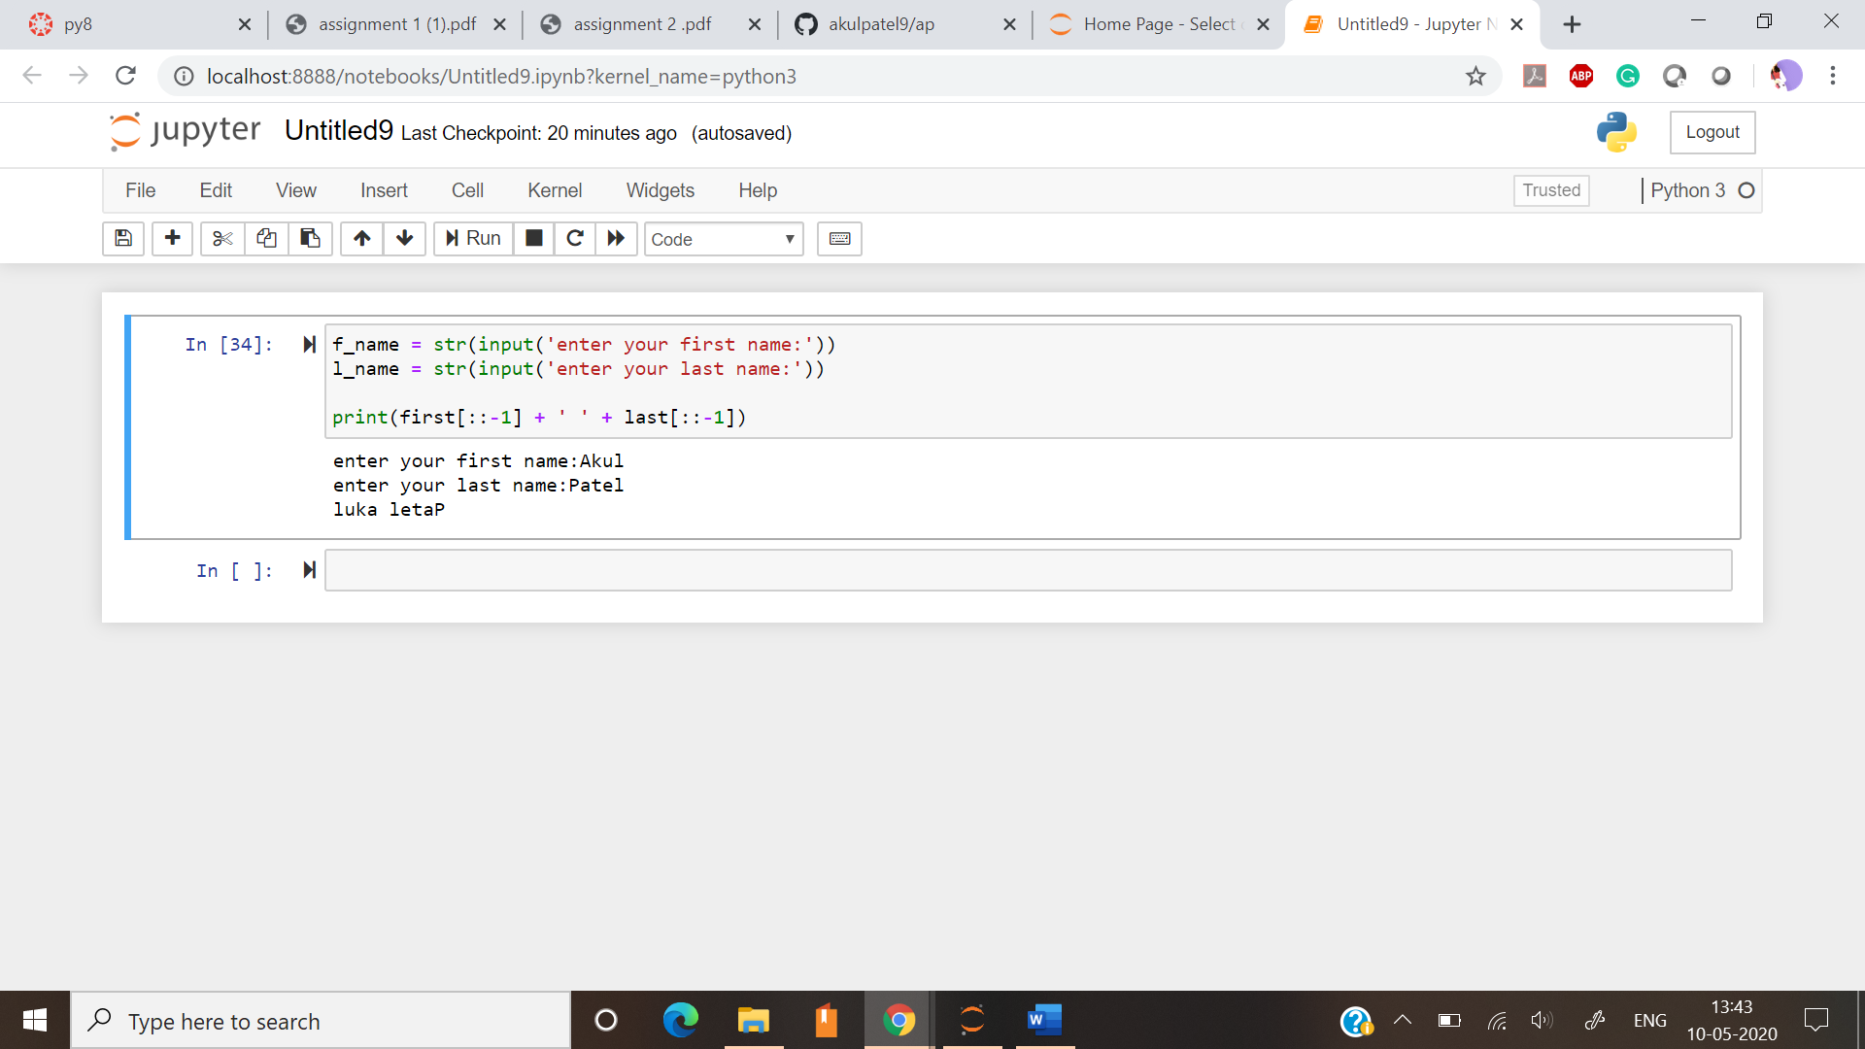

Q4. Write a Python program to find the volume of a sphere with diameter 12 cm.

Ans:

pi = 22/7

radius = float(12/2)

Volume = (float(4/3)*(pi)*(radius)**3)

print(Volume)

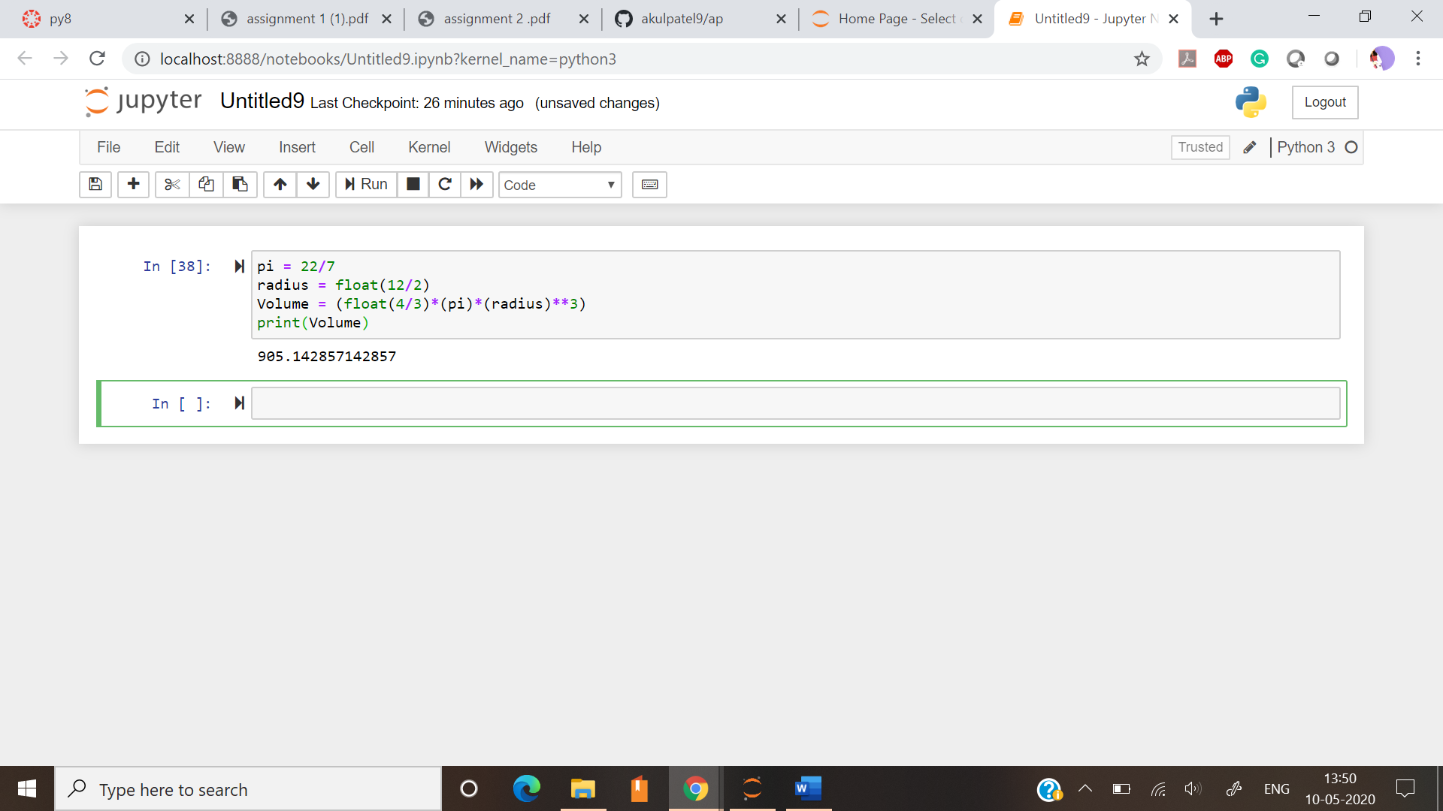

**Task 2:**

Q1.Write a program which accepts a sequence of comma-separated numbers from console and generate a list

Ans:

l = str(input())

li = l.split(',')

lis = list(li)

print(lis)

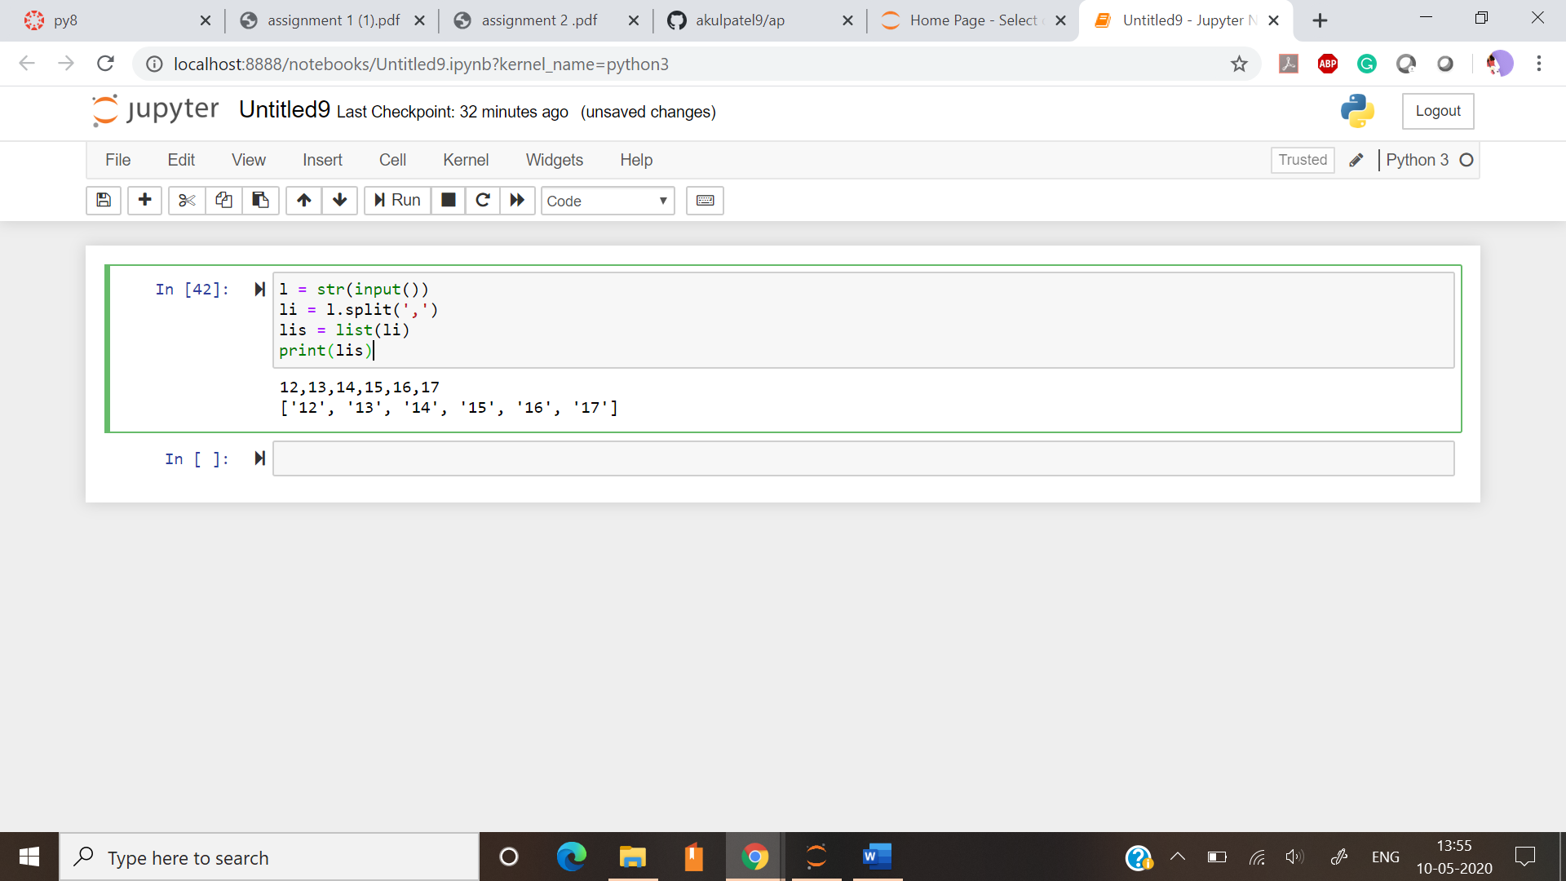

Q2.Create the below pattern using nested for loop in Python.

Ans:

for i in range(0, 5):

for j in range(0, i + 1):

print("*", end=' ')

print("\r")

for i in range(5, 0, -1):

for j in range(0, i - 1):

print("*", end=' ')

print("\r")

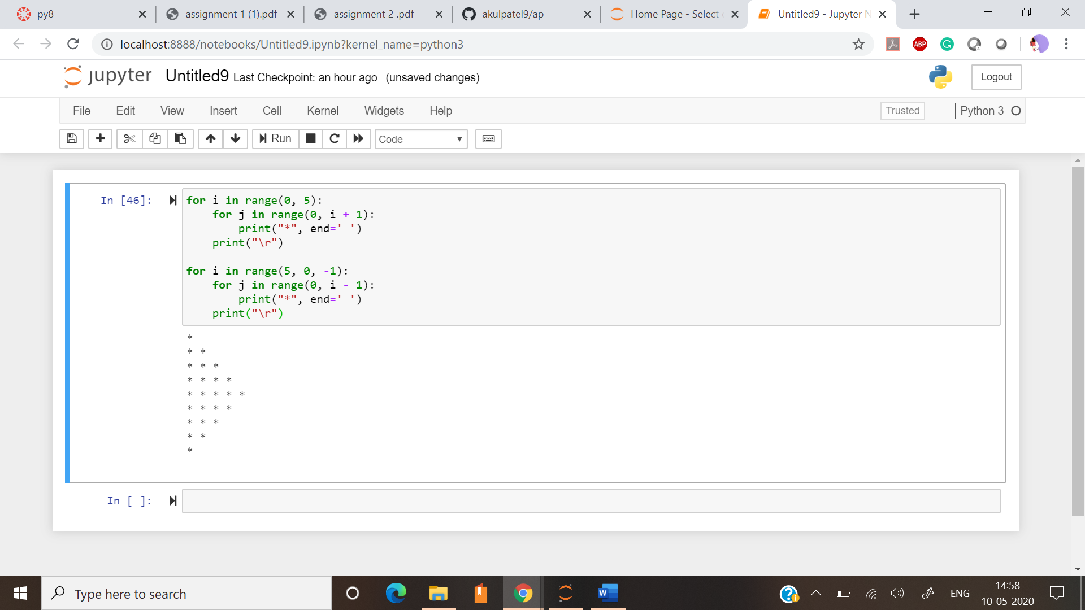

Q3.Write a Python program to reverse a word after accepting the input from the user.

Ans:

a = input("Enter a string: ")

print(a[::-1])

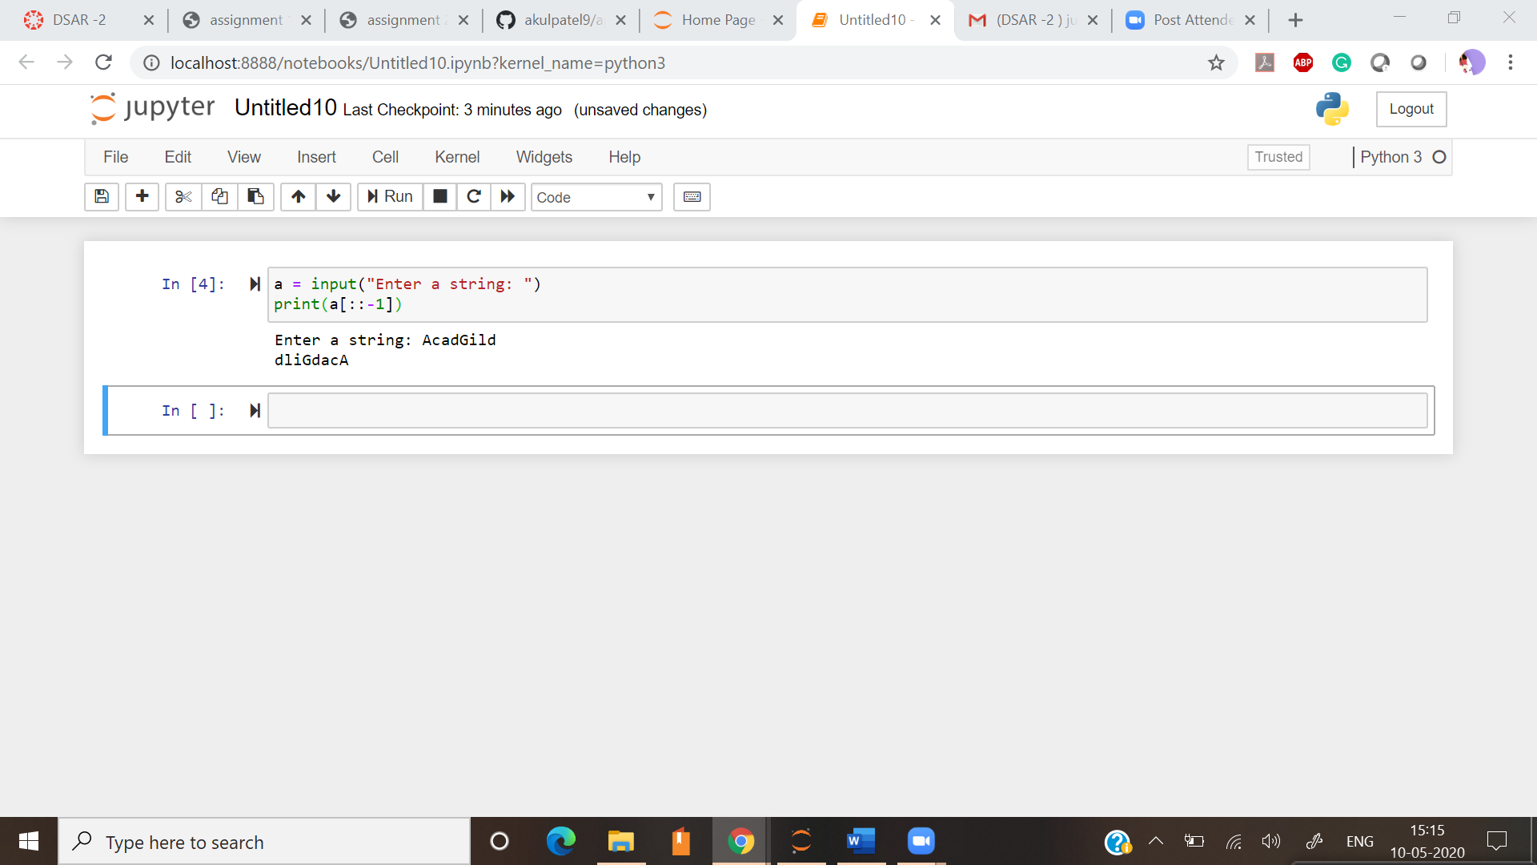

Q4. Write a Python Program to print the given string in the format specified in the sample output. WE, THE PEOPLE OF INDIA, having solemnly resolved to constitute India into a SOVEREIGN, SOCIALIST, SECULAR, DEMOCRATIC REPUBLIC and to secure to all its citizens.

Ans:

print("WE, THE PEOPLE OF INDIA,\n\thaving solemnly resolved to constitute India into a SOVEREIGN,! \n\t\tSOCIALIST, SECULAR, DEMOCRATIC REPUBLIC \n\t\t and to secure to all its citizens")

